**How to install MySQL Server, MySQL Workbench and to connect to Northwind database.**

Please, for the newest version of MySQL Server and MySQL Workbench, go to the official site <https://dev.mysql.com/downloads/installer/> and while installing, choose “Custom” installing.

After that, install MySQL Server and MySQL Workbench.

Then connect to Northwind database.

1. Open MySQL Workbench.

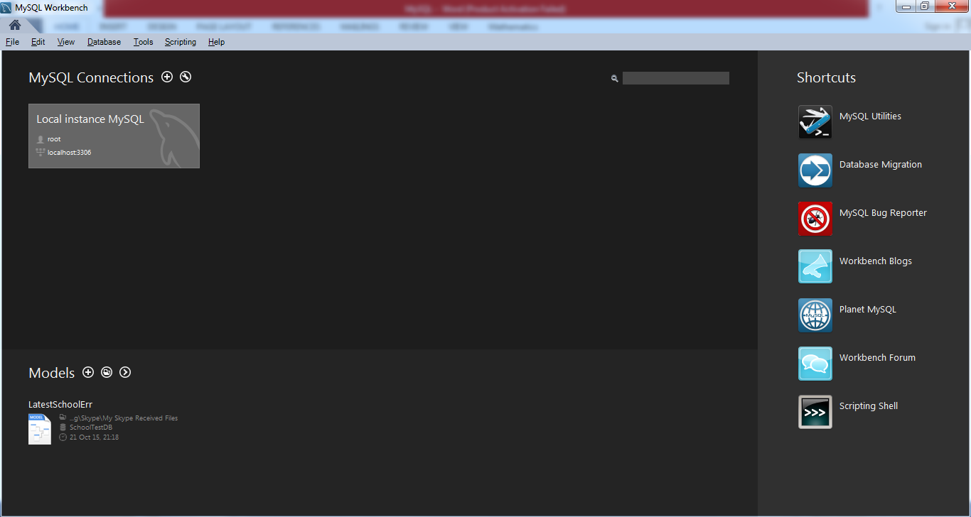 Figure 1. MySQL Workbench

1. Click “Local instance MySQL”.

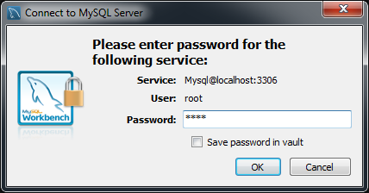

Figure 2. Connect to MySQL Server

1. Enter you root password and click “OK” button.

MySQL Workbench is opened.

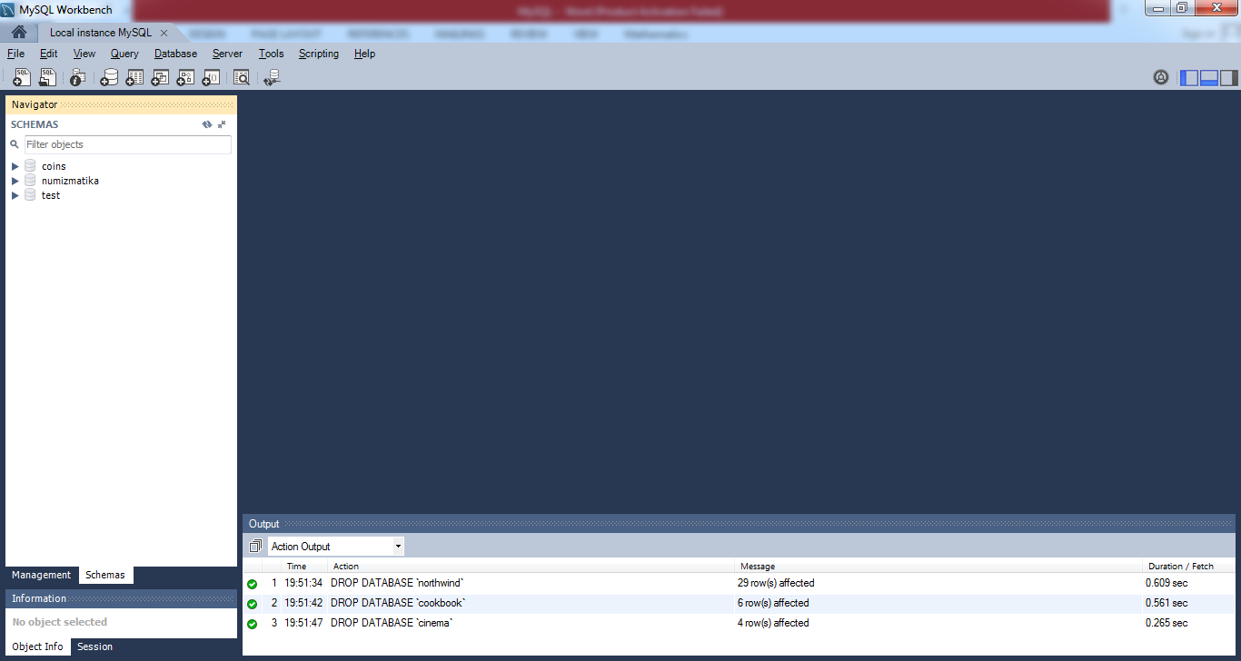

Figure 3. MySQL Workbench (1)

1. Now add Northwind database to MySQL Workbench. You should click “Create new schema in the connected in the server”.

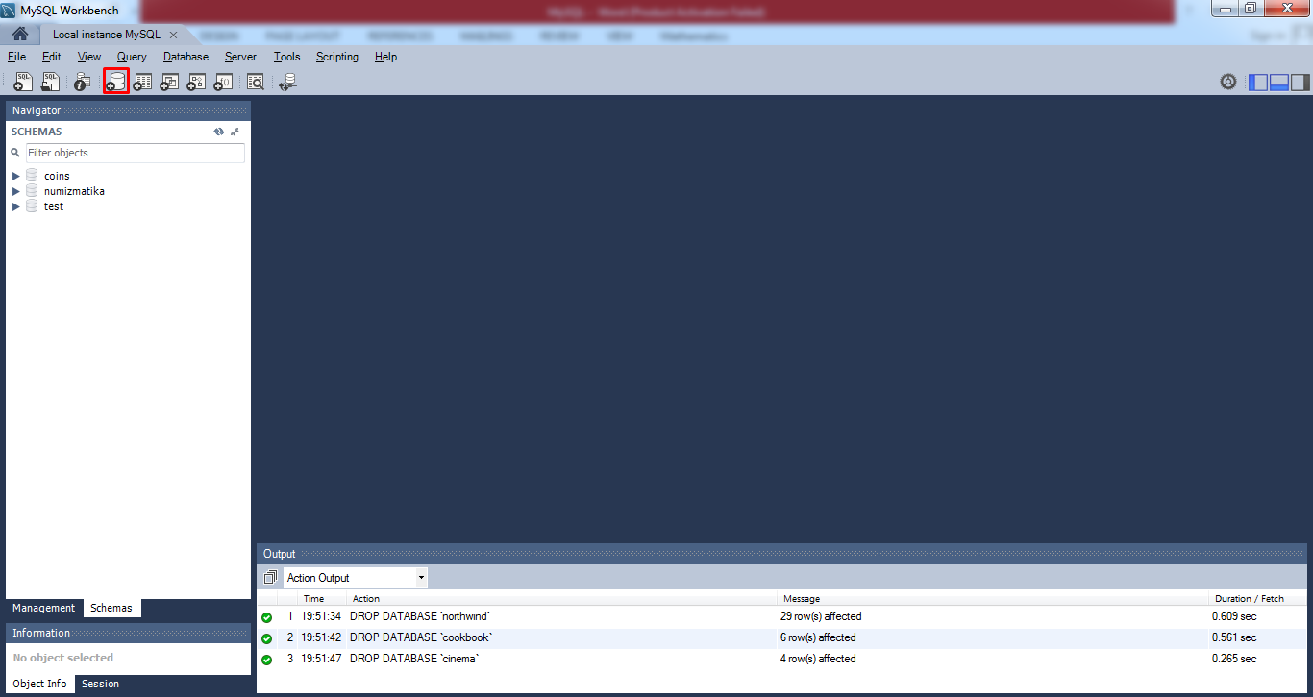

Figure 4. MySQL Workbench (2)

1. Click “Apply” button.

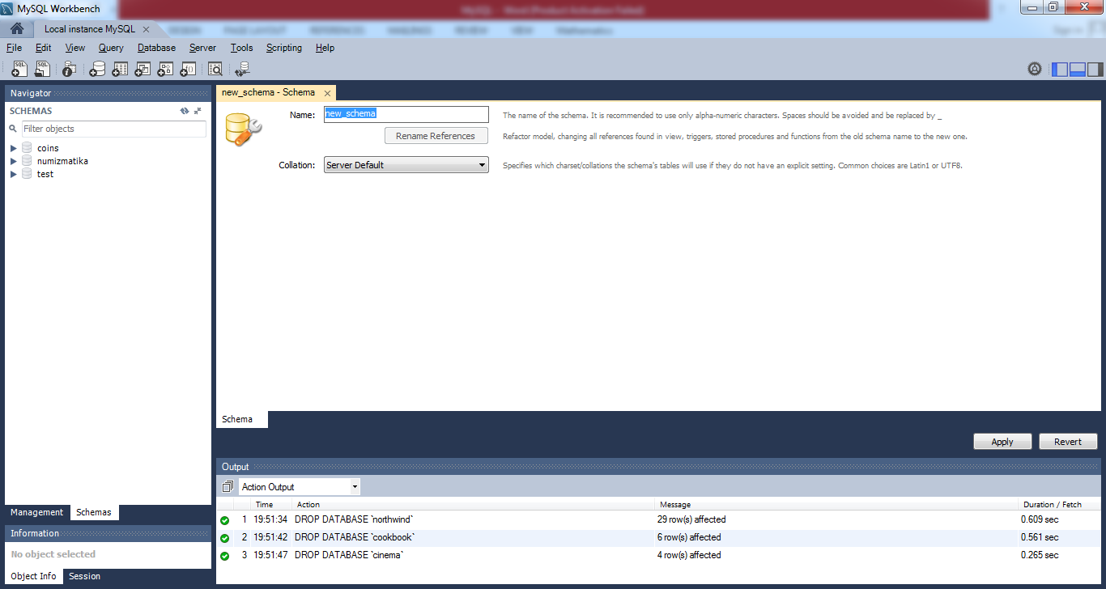

Figure 5. MySQL Workbench (3)

As a result, window is opened. Open Northwind.MySQL5.sql and copy code. Insert code in this window.

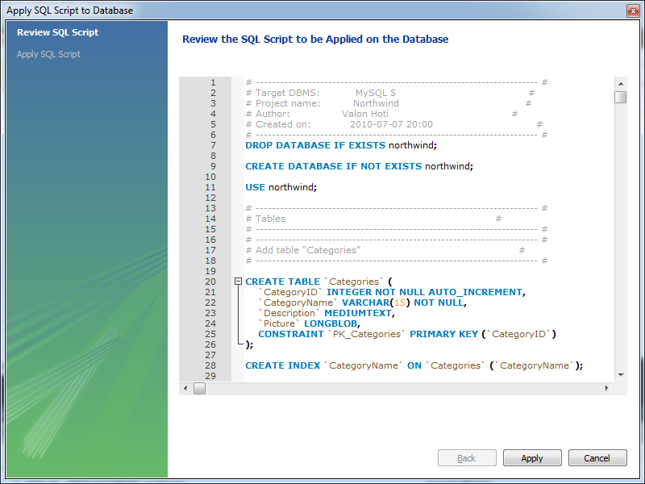

Figure 5а. Apply SQL Script to Database (1)

1. Click “Apply” button. You will see some errors, but it is fine. Also program can be stalled, but it is fine too. Close program and open again.

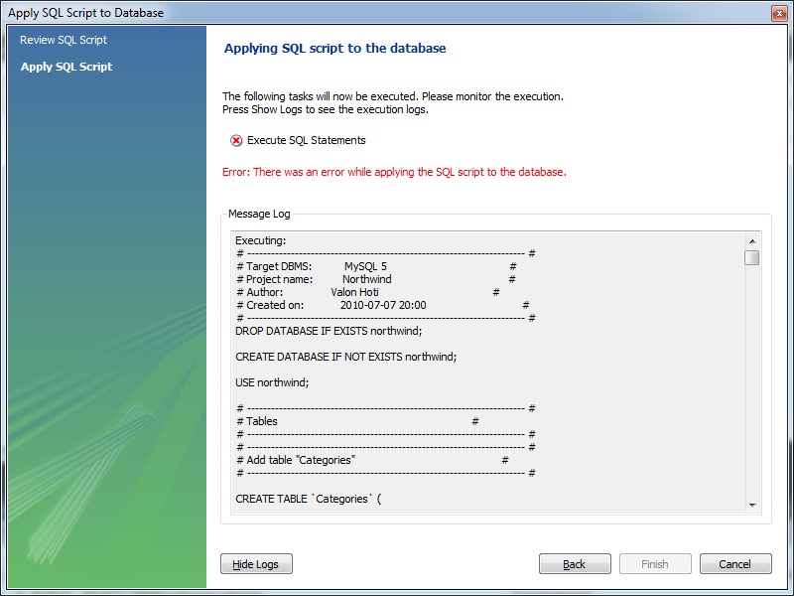

Figure 7. Apply SQL Script to Database (2)

1. Open MySQL Workbench again, click “Local instance MySQL”, enter your root password. Let’s check if database is created correctly. Select some table and select all information from this table (for example “customers”). If your result will be empty, then probably “Safe update mode” is enabled.

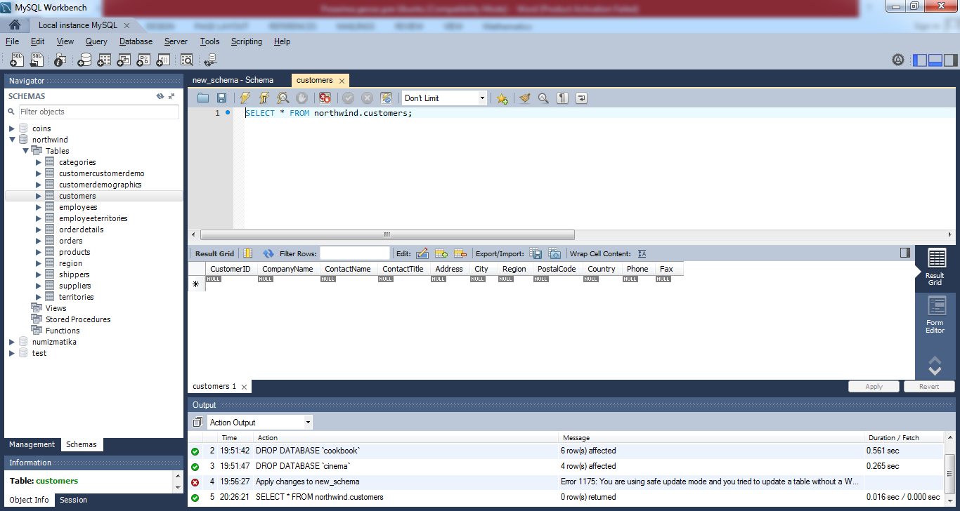

Figure 8. MySQL Workbench (4)

1. Go to Edit --> Preferences
2. Click "SQL Editor" tab and uncheck "Safe Updates" check box

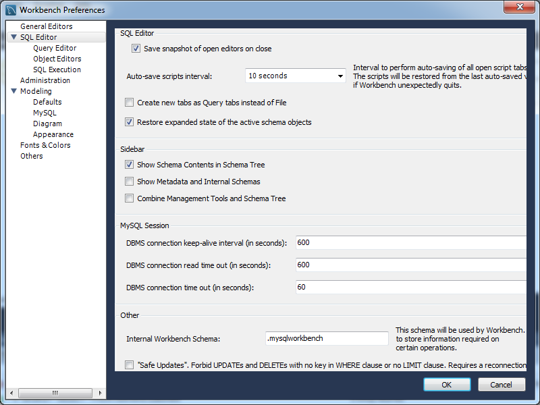

Figure 9. Workbench Preferences

1. Query --> Reconnect to Server // logout and then login
2. Now execute your SQL query.

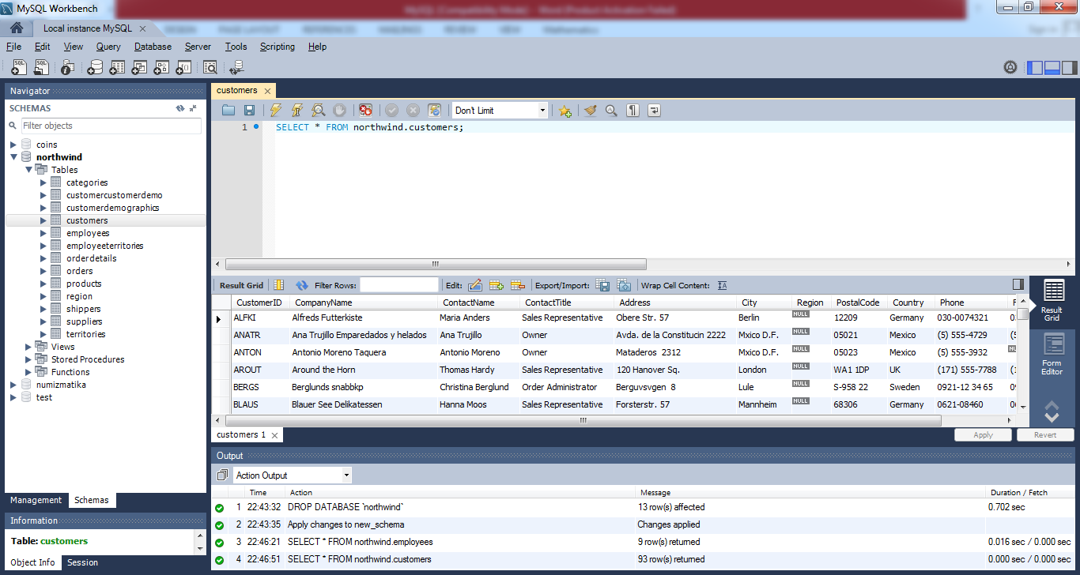

Figure 10. Northwind database